# Lecture 4. **Variables**

A *Variable* is a **named** storage location (memory location), that stores a **value** of a particular **data type**.

Declaration syntax: **data_type variable_name;**

where **data_type** represents the variable data type

**variable_name** is a variable name

Multiple variables of the same data type may be declared in the same statement where names are separate by commas.

Example: int number1, number2, sum;

Variables can be initiated in the declaration statement by using the **assignment operator** (**=**). Example: int number1 = 1;

Variable name

Since the variable names are identifiers, the naming convention must follow the rules given for identifiers.

* Every variable must be declared before it is used.
* Variable can only store a value of a specified data type.
* A variable may take different values during the program execution.
* Each declaration statement must end with semi-colon (;).
* Variable names may contain, but not begin with, an integer.
* Variable names should be descriptive

## Data types

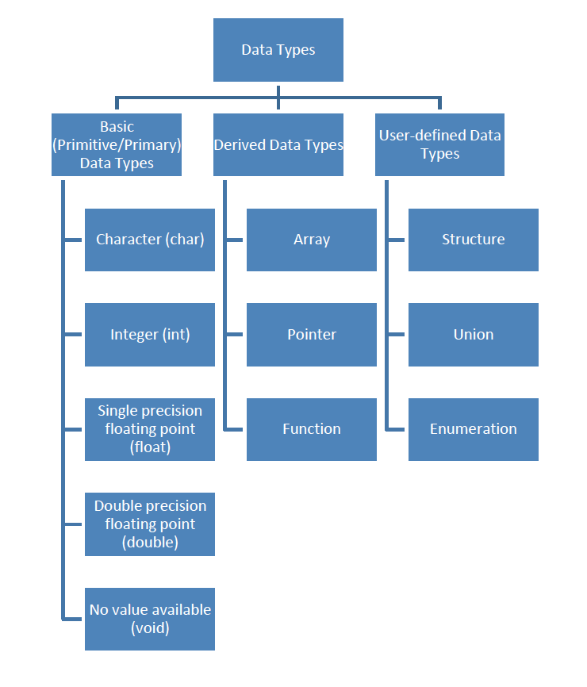

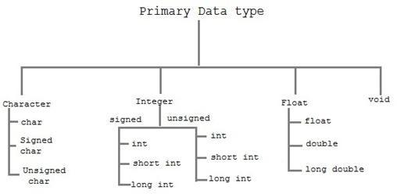

“Primary Data Type.” n.d. Online Image. Studytonight. 23 Jan, 2017. <http://www.studytonight.com/c/datatype-in-c.php>

Note: signed, unsigned, short, and long are **type modifiers**.

|  |  |  |  |
| --- | --- | --- | --- |
| Data Type | Keyword | Storage  size | Valuerange |
| Character | char | 1 byte | -128 to 127 or 0 to 255 |
| Unsigned character | unsigned char | 1 byte | 0 to 255 |
| Signed character | signed char | 1 byte | -128 to 127 |
| Integer | int | 2 OR  4 bytes | -32,768 to 32,767 OR  -2,147,483,648 to 2,147,483,647 |
| Unsigned integer | unsigned int | 2 OR  4 bytes | 0 to 65,535 OR  0 to 4,294,967,295 |
| Short integer | short int | 2 bytes | -32,768 to 32,767 |
| Unsigned short integer | unsigned short int | 2 bytes | 0 to 65,535 |
| Long integer | long int | 4 bytes | -2,147,483,648 to 2,147,483,647 |
| Unsigned long integer | unsigned long int | 4 bytes | 0 to 4,294,967,295 |
| Float | float | 4 bytes | -1.2E-38 to 3.4E+38  Precision: 6 decimal places |
| Double | double | 8 bytes | 2.3E-308 to 1.7E+308  Precision: 15 decimal places |
| Long double | long double | 10 bytes | 3.4E-4932 to 1.1E+4932  Precision: 19 decimal places |

The sizes and ranges of different variable types are compiler dependent. To get the exact size of a data type, the operator **sizeof()** can be used. The expression **sizeof(data_type)** will return a number of bytes required to store a particular data type.

# Constants (Literals)

A named memory location which holds a **fixed** value that cannot be modified by the program during its execution

Types of constants:

* Integer
  + Decimal – Example: 123
  + Octal – Using prefix 0. Example: 0123
  + Hexadecimal – Using prefix 0x or 0X. Example: 0x2A
* Floating point – Examples: 123.45, -0.2E-2
* Character
  + Examples: ‘A’, ‘1’, ‘&’
  + Special Backslash character constants – Example: ‘\n’
* String – Example: “Seneca”

Defining Constants

There are two ways to define a constant in C:

* using **#define** preprocessor Examples:
  + #define PI 3.14
  + #define NEWLINE ‘\n’
* using **const** keyword Examples:
  + const int SIZE = 100;
  + const float PI = 3.14;
  + const char NEWLINE = ‘\n’;

Example:

#include <stdio.h> #define SIZE 10

int main()

{

const float PI = 3.14; const char letter = 'A'; printf("pi=%.2f\n", PI);

printf("Section: %c\n", letter);

printf("size = 2 x %d = %d\n", SIZE, 2*SIZE); return 0;

}

# Function scanf()

**scanf()** function reads data from the input device (usually keyboard) and store it in a variable. To use scanf() function, you will have to include header **<stdio.h>** (same as for printf()).

Syntax: **scanf(“*format_string*”, &*variable1, &variable2, …*);**

where

* *format_string* – Specifies the data type of each variable from the list. Common format specifiers:

|  |  |
| --- | --- |
| Data Type | Format Specifier |
| int | %d |
| float | %f |
| double | %lf |
| char | %c |
| string | %s |

* *Ampersand sign (&)* – “Address of” operator
* Tells scanf() where (in memory) to store the new value entered by the user
* Missing & in scanf() is a common error; it leads to abnormal program termination.

Example:

int number;

printf("Enter a number: "); //User prompted to enter a number

scanf("%d", &number); /*scanf reads an int value from the keyboard and stores

it into variable number*/

After scanf() is called, the program waits for user to enter a value and press the “Enter” key.

scanf() can be used to enter multiple values, of different or same data types, as shown in the example below:

int age; float height;

printf("Enter your age and height: ");

scanf("%d%f", &age, &height); // %d is used for variable age, %f for height

## References

* Tan, H.H., and T.B. D’Orazio. *C Programming for Engineering & Computer Science*. USA: WCB McGRaw-Hill. 1999. Print.
* Hock-Chuan, Chua. *C programming Tutorial*. Programming notes, n.d. Web. 23 Jan, 2017.

<<https://www3.ntu.edu.sg/home/ehchua/programming/cpp/c1_Basics.html#zz-3.1>>

* Tutorialspoint.com. "C Data Types." *Www.tutorialspoint.com*. N.p., n.d. Web. 02 Mar. 2017.

<<https://www.tutorialspoint.com/cprogramming/c_data_types.htm>>.

* Tutorialspoint.com. "C Constants and Literals." *Www.tutorialspoint.com*. N.p., n.d. Web. 02 Mar. 2017. <<https://www.tutorialspoint.com/cprogramming/c_constants.htm>>.